RESLEN YASSINE | ID#201607180 | EMAIL: RWY05@MAIL.AUB.EDU
SARA ALAWIEH | ID#201601126 | EMAIL: SMA107@MAIL.AUB.EDU
10/16/2016

ECE 312L – CIRCUITS AND ELECTRONICS LAB
  - EXPERIMENT 4- RC CIRCUIT
SECTION 3 - GROUP 12
Table of Contents
I. OBJECTIVES: 2
II. LAB EQUIPMENT USED: 2
III. LAB TOOLS USED: 2
IV. COMPONENTS USED: 2
V. EXPERIMENTAL PROCEDURE AND DISCUSSION: 3
A. PHASE SHIFT MEASUREMENTS: 3
A1- CIRCUIT DIAGRAMS: 3
A2- DETAILED EXPERIMENTAL PROCEDURE: 3
A3- MEASUREMENTS AND RESULTS: 4
A4- DISCUSSIONS: 6
B. LEAD AND LAG NETWORKS: 7
B1- LAG NETWORKS: 7
B.1.1- CIRCUIT DIAGRAMS: 7
B.1.2- DETAILED EXPERIMENTAL PROCEDURE: 7
B.1.3- MEASUREMENTS AND RESULTS: 8
B.2.4- DISCUSSIONS: 15
B2- LEAD NETWORKS: 17
B.2.1- CIRCUIT DIAGRAMS: 17
B.2.2- DETAILED EXPERIMENTAL PROCEDURE: 18
B.2.3- MEASUREMENTS AND RESULTS: 18
B.2.4- DISCUSSIONS: 25
VI. REFERENCES: 27
VII. MISTAKES AND PROBLEMS FACED IN THE LAB: 27
VIII. SIGNATURE 28

OBJECTIVES:
IN THIS EXPERIMENT YOU WILL LEARN HOW TO:
- Investigate the frequency domain response and time response of RC circuits.
- Use the oscilloscope to do frequency, time, and phase measurements.

LAB EQUIPMENT USED:
- Oscilloscope (Tektronix TDS 220)
- Function generator (HP Agilent 3320A)
- Digital Multimeter (FLUKE 45 DMM)
- Breadboard
- Electric wires
- BNC-connectors
- Different probes
- Cables for the connections of equipment

LAB TOOLS USED:
No lab tools were needed for this experiment since wires were already stripped and cut and a breadboard was provided

COMPONENTS USED:
Component | Theoretical Value | Measured value | % Error
Resistor | 1 KΩ | 1.0004 KΩ | $$\frac{(1-1.0004)×100}{1}=0.04\%$$
Resistor | 20 KΩ | 19.594 KΩ | $$\frac{(20-19.594)×100}{20}=2.03\%$$
Capacitor | 0.1 µF | 0.1 µF | 0%
Capacitor | 1 nF | 1 nF | 0%

EXPERIMENTAL PROCEDURE AND DISCUSSION:

PHASE SHIFT MEASUREMENTS:

A1- CIRCUIT DIAGRAMS:
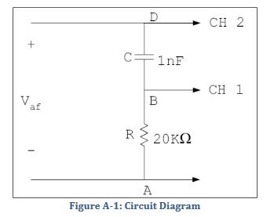
Figure 1: Showing the connections of capacitor and resistor in series along with the connection of the oscilloscope while the circuit is applied to a 6V PK-PK sinusoidal voltage.

A2- DETAILED EXPERIMENTAL PROCEDURE:
- First method:
Using a dual trace oscilloscope and the fact that a phase difference is equivalent to a time shift

- Start building the circuit by connecting the 20 KΩ resistor in series with the 1 nF capacitor on breadboard.
- Plug the probes of the function generator to the board
- Turn on the function generator and set it up by pressing utility, output setup, high z, and then output.
- Set the function generator to 6V PK-PK sinusoidal voltage V of frequency 5KHZ.
- Connect the ground of the oscilloscope to node A
- Connect CH1 of the scope to node B, between the capacitor and resistor.
- Connect CH2 to node D, between the generator and capacitor.
By these connections, you are now measuring V_{BA} across the resistor and V_{DA} across the series combination of the capacitor and resistor.
- Superpose the two traces of V_{BA} and V_{DA} to have the same horizontal axis.
- Adjust the VOLT/DIV and SEC/DIV settings to get stable traces.
- Using the measure button, measure V_{BA} and V_{DA} PK-PK along with the input voltage to make sure the connections are right.
- Place the vertical cursors on the peak of each trace.
- Using the measure button, measure ΔT and T.
Assume V_{AF} to be of the form 3sin (ωt) V and V_{BA} to be of the form V_{m} sin (ωt + ф)

- Second method:
Using the lissajous figure pattern and X-Y mode of function of the oscilloscope
- Leave the connections the same as in the previous part.
- Set the sweep rate to X-Y mode.
Now V_{BA} and V_{DA} are connected to the X and Y channels of the oscilloscope.
- As a result of superposing the two perpendicular signals V_{BA} and V_{DA,} observe an ellipse on the oscilloscope. ( called the lissajous figure)
- Adjust VOLTS/DIV controls of X and Y and use horizontal POSITION knobs to center the ellipse symmetrically as shown in the figure below:
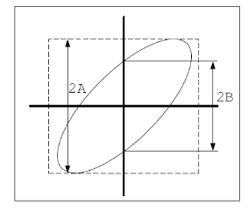
Figure 2: The lissajous figure, where 2A is the full length and 2B is the distance between the 2 points where the ellipse crosses the Y-axis

A3- MEASUREMENTS AND RESULTS:
Calculated (theoretical) value of ф:
Using the formula tanф $=\frac{Xc}{R}$
Where Xc= $\frac{1}{ωc}=\frac{1}{2πfc}$
f= 5 KHz
R= 20 KΩ
C= 1 nF
So tanф= $\frac{Xc}{R}$ = $\frac{31830.9886}{20 ×{10}^{3}}$ = 1.591549
Ф = tan⁻¹ (1.591549) = 57.8580°
Results found in the lab:
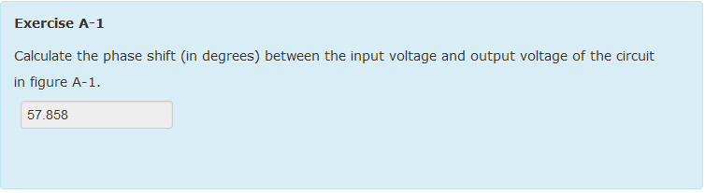
Figure 3: The theoretical/calculated value for phase shift

Measured value:
- For the first method:
The phase difference can be measure from time instants at which the waveforms cross the time axis:
Ф = $\frac{360 ×ΔT}{T}$
Results found in the lab:
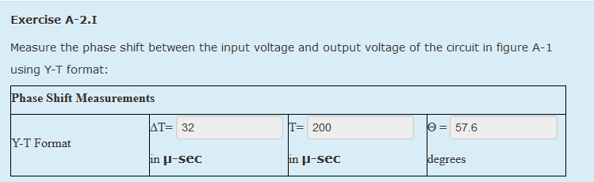
Figure 4: The measured value for the phase shift by the first method.

Comparison between the theoretical and measured values:
% error = $\frac{57.858-57.6}{57.858}×100$ = 0.4479%
The values are acceptable since the error is less than 5%
- For the second method:
ф= sin⁻¹ $(\frac{B}{A})$

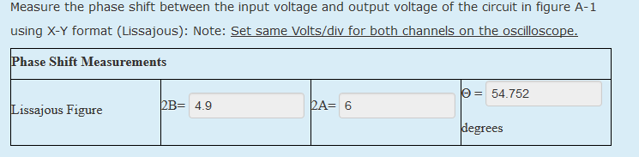
Results found in the lab:
Figure 5: The measured value for the phase shift by the second method
Comparison between the theoretical and measured values:
% error = $\frac{57.858-54.752}{57.858}×100$ = 5.3683%
Measurements are of very accurate since the % error is greater than 5%.
Errors may have occurred due to a mistake in counting the number of divisions for 2A and 2B or loose cables that were affecting the accurate readings of the oscilloscope.

A4- DISCUSSIONS:
Change the frequency and observe the change in the lissajous figure:
- At very low frequencies, $\lim_{f→0}{Zc}$ = $\lim_{f→0}{\frac{1}{jwc}}$ = $\lim_{f→0}{\frac{1}{j2πfc}}$ = ∞
So the capacitor acts as an open circuit (I tends to zero)
Thus, V_{out} across the resistor also tends to zero and a vertical line at the origin is observed.
The ellipse takes the shape of a vertical line.
- At very high frequencies, $\lim_{f→∞}{Zc}$ = $\lim_{f→∞}{\frac{1}{jwc}}$ = $\lim_{f→∞}{\frac{1}{j2πfc}}$ = 0
So the capacitor acts as a short circuit, voltage across the capacitor is zero.
Thus, V_{out} is only the voltage across the resistor represented using ohm’s law by: V=RI. The voltage and current have a linear relation, so the voltage is represented by a straight line.
The ellipse takes the shape of a vertical line.

LEAD AND LAG NETWORKS:

B1- LAG NETWORKS:

B.1.1- CIRCUIT DIAGRAMS:
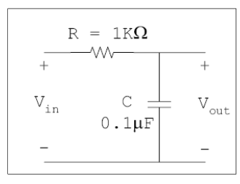
Figure 6: Showing the series connection of the capacitor and resistor when the circuit is applied to a 1V PK-PK sinusoidal signal

B.1.2- DETAILED EXPERIMENTAL PROCEDURE:
The experiment is divided into two parts:

- Build the circuit by connecting the 1 KΩ resistor in series with the 0.1 µF capacitor on the breadboard.
- Plug the probes of the function generator to the breadboard.
- Set the function generator to 1V PK-PK sinusoidal wave.
- Start with frequency of 100 Hz on the function generator.
- Connect CH1 of the oscilloscope across the function generator (V_{in}) and CH2 across the capacitor (V_{out})
- Choose the Y-T mode of function of the oscilloscope and press “AUTO-SET”
- Observe the input and output waveforms on the oscilloscope and record your results.
- Repeat for sinusoidal wave of different frequencies 1KHz and 10KHz.

B.1.3- MEASUREMENTS AND RESULTS:
V_{out} calculated value:
Apply voltage divider rule to calculate V_{out}
V_{out} = V_{in} $\frac{Zc}{Zc+R}$ so that | V_{out} |= |V_{in}| $\frac{Xc}{{√Xc}^{2}+R^{2}}$
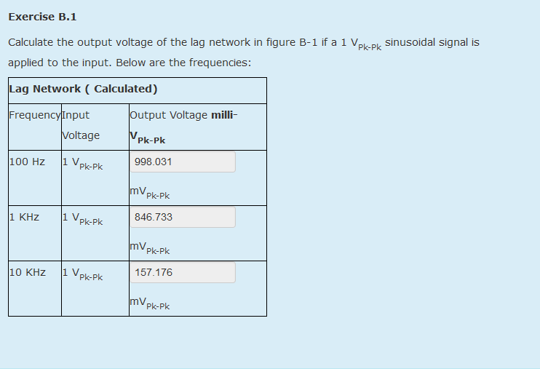
Results found in the lab:
Figure 7: The calculated value of Vout PK-PK for different frequencies

Measured Values:
- Sinusoidal waveforms:
Recording the results from the oscilloscope
Results found in the lab:
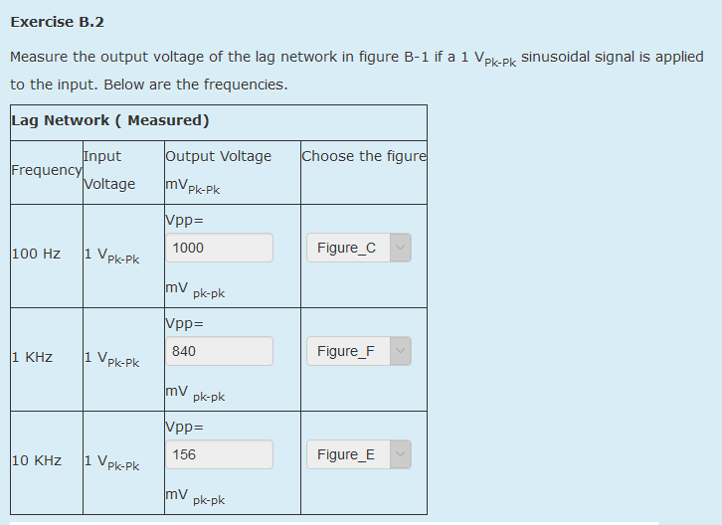
Figure 8: The measured value of Vout PK-PK for the different frequencies and a sinusoidal waveform

Comparison between the theoretical and measured values:
Frequency (Hz) | Theoretical Value mV | Measured Value mV | % Error
100 Hz | 998.031 | 1000 | $$\frac{\left(998.031-1000\right)×100}{998.031}=0.1972\%$$
1 KHz | 846.733 | 840 | $$\frac{(846.733-840)×100}{846.733}=0.7951\%$$
10 KHz | 157.176 | 156 | $$\frac{(157.176-156)×100}{157.176}=0.7482\%$$

Graphs:
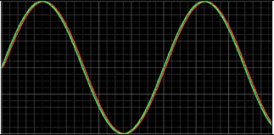
Figure 9: 100 Hz lag network with sinusoidal waveforms

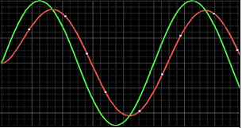
Figure 10: 1 KHz lag network with sinusoidal waveforms

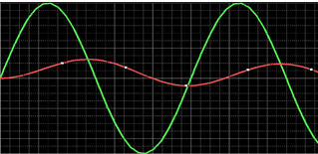
Figure 11: 10 KHz lag network with sinusoidal waveforms

- Square waveforms:
Repeating the same process but now for a 1V PK-PK square signal:
Measured value:
Recording the results from the oscilloscope
Results found in the lab:
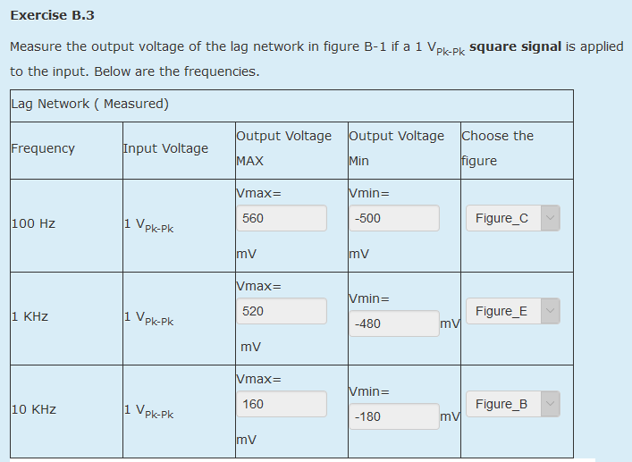
Figure 12: Measured values for the output voltage for different frequencies and square waveforms

Comparison between the theoretical and measured values:

Frequency (Hz) | Theoretical Value mV | Measured Value mV | % Error
100 Hz | 998.031 | 1060 | $$\frac{\left(998.031-1060\right)×100}{998.031}=6.02091\%$$
1 KHz | 846.733 | 1000 | $$\frac{(846.733-1000)×100}{846.733}=27.8802\%$$
10 KHz | 157.176 | 340 | $$\frac{(157.176-340)×100}{157.176}=116.3180\%$$

Graphs:
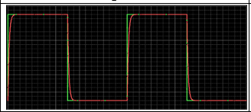
Figure 13: 100 Hz lag network with square waveforms

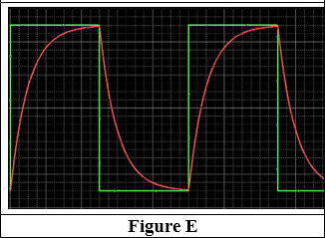
Figure 14: 1 KHz lag network with square waveforms

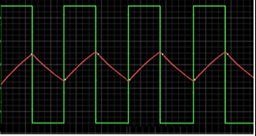

Figure 15: 10 KHz lag network with square waveforms

B.2.4- DISCUSSIONS:

- The graph of the output waveforms starts off matching the square waveforms at low frequencies. As the frequency increases, the output waveforms approach zero.
When the frequency is so small, the period is very high, larger than 5RC that is the time needed for the capacitor to charge, giving the capacitor the chance to charge completely and allow all the signal to pass.
Knowing that the transfer function of the network is given by:
- H (f) = $\frac{Vout}{Vin}$= $\frac{1}{1+jwRC}$
As f tends to infinity, H (f) tends to zero, so Vout approaches zero.
As f tend to zero, H (f) approaches 1, so that Vout is approximately equal to Vin and almost all the input signal appears in the output. In this case, the square signal is not distorted.
Knowing that a capacitor takes 5τ to charge completely, where τ= RC.
In order to have no distortions, ½ T must be greater than 5τ so T must be greater than 10 τ. And T= $\frac{1}{F}$ so F must be less than$\frac{1}{10 τ}$, which is the case of low frequencies.

- For the sinusoidal waveforms, at low frequencies the same way we reasoned the previous case, the transfer function tends to 1, thus there is no distortion in the output. For no distortions, f must also be less than 1/10taw.

- In this network, the transfer function given by:
H (f) = $\frac{1}{1+jwRC}$
Represents a low pass response, where H (f) equals to one at low frequencies, and zero at high frequencies. i.e.: low frequency signals pass without distortions. Distortions increase with the increase of frequency. Thus, high frequencies are blocked or highly distorted.
The cut off frequency is the frequency where the transform function magnitude is $\frac{1}{√2}$of its maximum value. For a low pass filter, the cutoff frequency represents a limit frequency where the filter passes the frequencies below it and blocks any frequency above it.
The cut off frequency is given by: $\frac{1}{RC}$ (in rd/sec) or $\frac{1}{2πRC}$ (in hertz).
In our case Fc= 1591.549 Hz
In a low pass-filter the phase shift is given by:
ф= 0- arc tan (2πfRC)
At very low frequencies, ф approaches zero.
At very high frequencies, ф approaches 90 degrees.
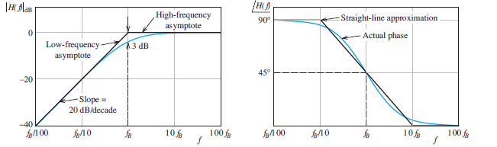
Figure 16: Magnitude Bode plot and phase plot for first-order low pass filter

- According to Fourier theorems, all real world signals are sums of sinusoidal components having various frequencies, amplitudes, and phases. In the case of a lag network, where the circuit acts as a low pass filter, most of the frequencies forming the shape are below the cut-off frequency. In such filters, the vertices of the square waves are all distorted because they have the largest frequency. This is why we observe similarities between the behavior of the square and sinusoidal waveforms in terms of attenuation and distortion because studying a square wave at a specific frequency is actually picking one sinusoidal part of it and performing the study on this specific part.
When F is greatly higher than$\frac{1}{10 τ}$, the capacitor has no enough time to charge Zc= $\frac{1}{jwC}$ tends to zero s f tends to infinity, so the capacitor acts as a short circuit. The circuit becomes a resistive one where I is then approximated according to ohm’s law by $\frac{Vin}{R}$ and since Vc is given by Vc = ($\frac{1}{C}$)$\int{idt}$ then Vc= ($\frac{1}{RC}$)$\int{Vindt}$ and the circuit is an integration circuit where the ouput is the integral of the input. The input is constant along a period, and when we integrate a constant we get a linear function representing Vout that is across the capacitor
such as the case of 10 KHz graph where the output appeared as triangular signal with slope equal to the peak value.

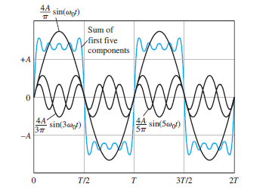
Figure 17: A square wave and some of its components

B2- LEAD NETWORKS:

B.2.1- CIRCUIT DIAGRAMS:
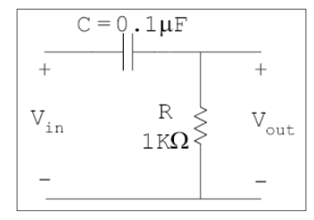
Figure 18: Showing the series connection of the capacitor and resistor when the circuit is applied to a 1V PL-PK sinusoidal signal

B.2.2- DETAILED EXPERIMENTAL PROCEDURE:
The experiment is divided into two parts:

- Build the circuit by connecting the 1 KΩ resistor in series with the 0.1 µF capacitor on the breadboard.
- Plug the probes of the function generator to the breadboard.
- Set the function generator to 1V PK-PK sinusoidal wave.
- Start with frequency of 100 Hz on the function generator.
- Connect CH1 of the oscilloscope across the function generator (V_{in}) and CH2 across the resistor instead of the capacitor (V_{out})
- Choose the Y-T mode of function of the oscilloscope and press “AUTO-SET”
- Observe the input and output waveforms on the oscilloscope and record your results.
- Repeat for sinusoidal wave of different frequencies 1KHz and 10KHz.

B.2.3- MEASUREMENTS AND RESULTS:
V_{out} calculated value:
Apply voltage divider rule to calculate V_{out}
V_{out} = V_{in} $\frac{R}{Zc+R}$
| V_{out} |= |V_{in}| $\frac{R^{2}}{{√Xc}^{2}+R^{2}}$

Results found in the lab:
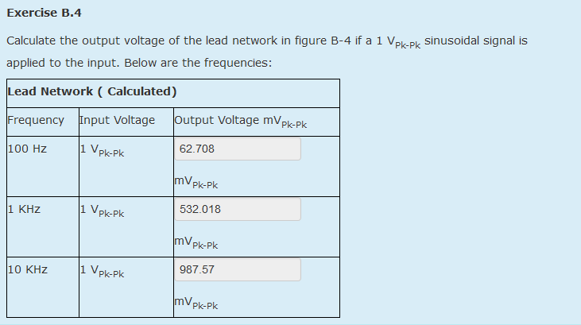
Measured Values:
Figure 19: Measured values for V_{out} PK-PK for different frequencies
- Sinusoidal waveforms:
Recording the results from the oscilloscope
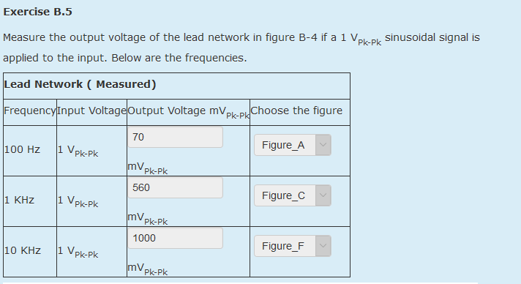
Results found in the lab:
Figure 20: Measured values for V_{out} PK-PK for different frequencies and sinusoidal waveforms

Comparison between the theoretical and measured values:

Frequency (Hz) | Theoretical Value mV | Measured Value mV | % Error
100 Hz | 62.708 | 70 | $$\frac{\left(62.708-70\right)×100}{62.708}=11.6287\%$$
1 KHz | 532.018 | 560 | $$\frac{(532.018-560)×100}{532.018}=5.2895\%$$
10 KHz | 987.57 | 1000 | $$\frac{(987.57-1000)×100}{987.57}=1.2586\%$$

Graphs:
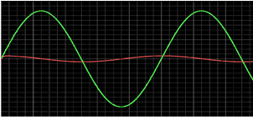

Figure 21: 100 Hz lead network with sinusoidal waveforms

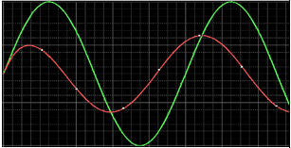
Figure 22: 1 KHz lead network with sinusoidal waveforms
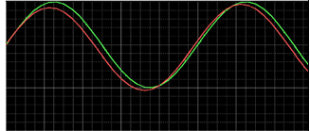
Figure 23: 10 KHz lead network with sinusoidal waveforms

- Square waveforms:
Repeating the same process but now for a 1V PK-PK square signal:
Measured value:
Recording the results from the oscilloscope:
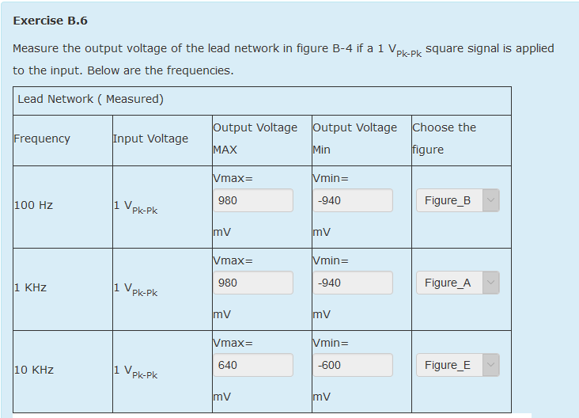
Results found in the lab:
Figure 24: Measured values for output voltage for different frequenices and square waveforms

Comparison between the theoretical and measured values:
Frequency (Hz) | Theoretical Value mV | Measured Value mV | % Error
100 Hz | 62.708 | 1920 | $$\frac{\left(62.708-1920\right)×100}{62.708}=2953.8368\%$$
1 KHz | 532.018 | 1920 | $$\frac{(532.018-1920)×100}{532.018}=260.8900\%$$
10 KHz | 987057 | 1240 | $$\frac{(987.57-1240)×100}{987.57}=25.5607\%$$

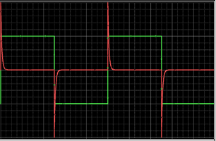
Graphs:
Figure 25: 100 Hz lead network with square waveforms

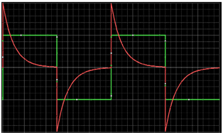
Figure 26: 1 KHz lead network with square waveforms

Figure 27: 10 KHz lead network with square waveforms

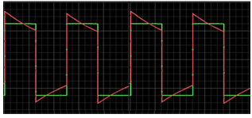

B.2.4- DISCUSSIONS:
- The graph of the output waveforms start off approximately zero at low frequency and tends to approach the square waveforms as the frequency increases.
When the frequency is so high, the period is very low, giving the capacitor no enough time to charge thus it won’t have any remarkable voltage across its terminals so that the output voltage that is the voltage across the resistor is approximately equal to the input voltage with almost no distortion. As the frequency decreases, the period increases, giving the capacitor more time to charge thus having remarkable voltage across it’s terminals and causing distortions.
Knowing that the transfer function of the network is given by:
H (f) = $\frac{Vout}{Vin}$= $\frac{jwRC}{1+jwRC}$
As f tends to zero, H (f) tends to zero, so V_{out} approaches zero.
As f tend to infinity, H (f) approaches 1, so that V_{out} is approximately equal to V_{in} and almost all the input signal appears in the output. In this case, the square signal is not distorted.
Since here Vout is taken across the resistor and Knowing that a capacitor takes 5τ to charge completely, where τ = RC.

- In order to have no distortions, ½ T must be less than 5τ so T must be less than 10τ.
And T= $\frac{1}{F}$ so F must be greater than$\frac{1}{10 τ}$, which is the case of high frequencies.
For the sinusoidal waveforms, at high frequencies the same way we reasoned the previous case, the transfer function tends to 1, thus there is no distortion in the output. For no distortions, f must also be greater than$\frac{1}{10 τ}$.

- In this network, the transfer function given by:
- H (f) = $\frac{Vout}{Vin}$= $\frac{jwRC}{1+jwRC}$
Represents a high pass response, where H (f) equals to one at high frequencies, and zero at low frequencies. i.e.: high frequency signals pass without distortions. Distortions increase with the decrease of frequency. Thus, low frequencies are blocked or highly distorted.
For a high pass filter, the cutoff frequency represents a limit frequency where the filter passes the frequencies above it and blocks any frequency below it.
The cut off frequency is given by: $\frac{1}{RC}$ (in rd./sec) or $\frac{1}{2πRC}$ (in hertz).
In our case Fc= 1591.549 Hz
In a high pass-filter the phase shift is given by:
ф= 90-arctan (2πfRC)
At very high frequencies, ф approaches zero.
At very low frequencies, ф approaches 90 degrees.
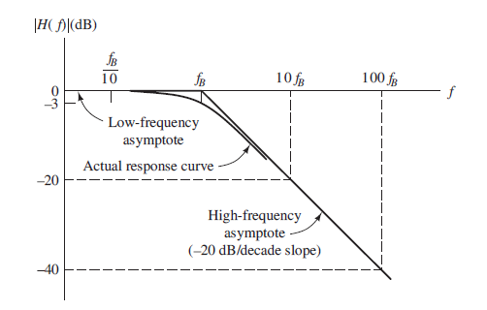
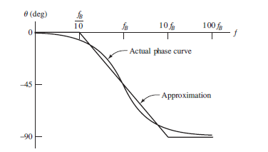
Figure 28: Phase plot for the first-order low pass filter
Figure 29: Magnitude Bode plot for first-order low pass filter

- Based on Fourier theorems, in the case of a lead network, where the circuit acts as a high pass filter, most of the frequencies forming the shape are above the cut-off frequency.
An important property in the capacitor’s voltage is the overshoot of the of the output voltage above the input voltage of the resistor.
- At low frequencies, the period is high, giving the capacitor enough time to charge and reach saturation, thus acts as an open circuit so no current passes through the resistor and the voltage across the capacitor now is approximately equals to the voltage of the input. When the sine wave switches to negative, the voltage across the capacitor doesn’t change instantaneously Vc (o+) = Vc (0- )
Applying KVL, we get:
Vr - Vin+ Vc = 2Vinput. This explains why the output voltage is greater than the input.
- When F is smaller than$\frac{1}{10 τ}$, the capacitor has enough time to charge and Zc= $\frac{1}{jwC}$tends to infinity as f tends to zero, so the capacitor acts as an open circuit With Vc= Vin. But since I is given by I= $\frac{CdVc}{dt}$ and Vr according to Ohm’s law is V=RI, then Vr= R ($\frac{CdVc}{dt}$) = R($\frac{CdVin}{dt})$ and the circuit is a differentiation circuit where the output is the proportional to the derivative of the input. This was clearly shown in the graph of the 100 Hz frequency where the output appeared as impulses. These impulses are the derivatives of the pulse function that forms the square wave.

REFERENCES:
- Lab manual, Lab notes, and in lab for experiment 4
- Electrical Engineering, Principles and Applications, Fifth Edition, Allan R. Hambley
- http://www.allaboutcircuits.com/textbook/alternating-current/chpt-7/square-wave-signals/

MISTAKES AND PROBLEMS FACED IN THE LAB:
Some mistakes occurred during measurements due to the resistance of the wires, loose wires, inaccurate measurements of the devices, and imprecision in counting divisions displayed on the oscilloscope. These all resulted in inaccurate measurements and increase in the percentage of error.

SIGNATURE

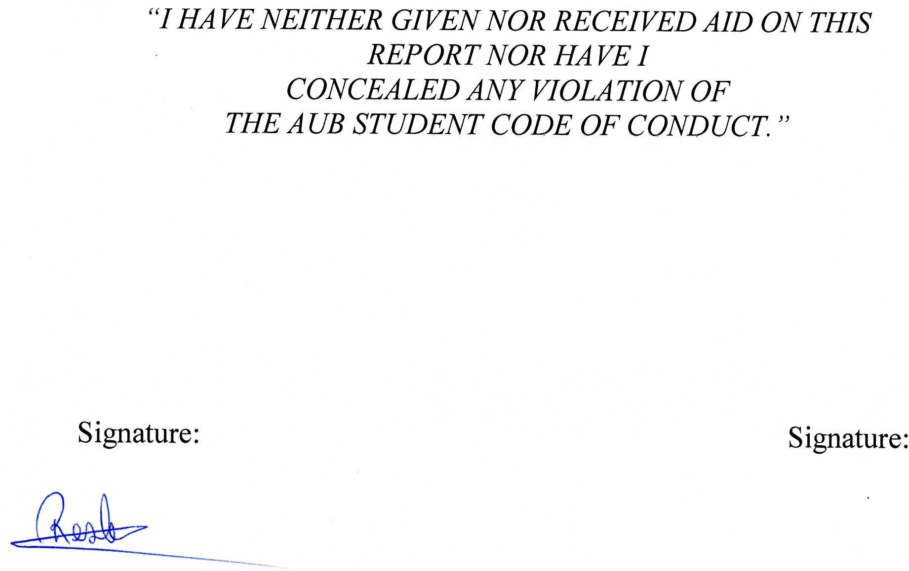

% error = $\frac{|Theoretical value-Measure value|}{Theoretical value} ×100$
Figure 13
Figures 23,24,25
Figure 23

